Article title (less than 15 words, Bold Cambria 14)

First Author^{1*}, Second Author², Third Author³ (Bold Cambria 10)

^{1*} Mechanical Engineering Department, Sharif University of Technology, Tehran, Iran | email@email.com (Cambria 8)
² Mechanical Engineering Department, Technical and Vocational University (TVU), Tehran, Iran | email@email.com (Cambria 8)
³ Faculty of Mechanical Engineering, Semnan University, Semnan, Iran | email@email.com (Cambria 8)

Abstract
Both Persian and English abstracts should be located only at the first page of the article. The abstract should clearly state, the objective, results and the conclusion of the work. It must be limited between 200 to 400 words. The space between lines in the whole manuscript should be 1 line. Each A4 page is prepared in 20 mm margin in the left and right rounds, and 25 mm in the top and from the end. The conference proceeding will be published through the first page of articles (including the abstract only). If this template has not been exactly followed by authors, then the article will not be reviewed.

Keywords: a maximum of five keywords, separate the words with ",".

عنوان مقاله (كمتر از 15 كلمه با قلم B Mitra و اندازة 16 پررنگ)

نویسنده اول^{1*}، نویسنده دوم²، نویسنده سوم³ (قلم B Mitra و اندازة 12 پررنگ)

^{1*}وابستگی سازمانی نویسندة اول و مسئول، مثال: دانشکده مهندسی مکانیک، دانشگاه صنعتی شریف، تهران، ایران | email@email.com (Cambria 8)
² وابستگی سازمانی نویسندة دوم، مثال: گروه مهندسی مکانیک، دانشگاه ملی مهارت، تهران، ایران | email@email.com (Cambria 8)
³ وابستگی سازمانی نویسندة سوم، مثال: دانشکده مهندسی مکانیک، دانشگاه سمنان، سمنان، ایران | email@email.com (Cambria 8)

چكيده
هر دو چکیدههای فارسی و انگلیسی فقط باید در صفحه اول مقاله قرار بگیرند. چکیده فارسي مقاله، با قلم B Mitra و اندازة 12 عادی و بصورت تکستونی نوشته شود. چکیده انگليسي مقاله، با قلم Cambria و اندازة 10 عادی و بصورت تکستونی نوشته شود. فاصله همه خطوط در مقاله، 1 باشد. چكيدة مقاله بايد بطور صريح، موضوع، اهداف، روش‌هاي به‌كارگرفته‌شده، دستاوردها و نتايج پژوهش انجام شده را مطرح كند؛ يعني بيان كند كه چه كاري، چگونه و به چه منظور انجام شده و چه نتيجه‌اي حاصل شده است. در چكيده، نبايد هيچ‌گونه جزييات، جدول، شكل يا معادله‌اي درج شود. چكيده فارسي و انگليسي بايد بصورت تك‌ستوني، بين 200 تا 400 كلمه (فقط در صفحه اول مقاله)، حروف‌چيني شود. فاصله از بالا و پايين صفحه، 2.5 سانتيمتر و فاصله از سمت چپ و راست بايد 2 سانتيمتر باشد. مجموعه مقالات کنفرانس، مستقيماً از فايل الکترونيکي مقالات که نويسندگان تهيه مي‌کنند، ايجاد مي‌شود. لذا متذکر ميگردد؛ مقالاتي که بصورت کامل، آيين نگارش را رعايت ننموده باشند، اولويت پيگيري و اعمال فرآيند داوري را از دست خواهند داد.
cm5/2 فاصله از پايين
کليدواژهها: حداكثر بايد 5 كليدواژه، انتخاب شده و پس از چكيده، با فاصله يك خط بيايد. بين كلمات از كاما (،) استفاده شود.

Introduction
Please use the following guidelines in preparing your full paper. If papers are not prepared according to the following guidelines, they will be withdrawn from the conference program.
All papers must be written in either English or Persian (Farsi). Paper will be presented in the language that it is written. There will be separate English and Persian sessions.

Elements of a Paper
The basic elements of a paper are listed as following in the order in which they should appear:
1) Paper title
2) Author names
3) Abstract
4) Keywords
5) Introduction
6) Main body of paper, including figures and tables, footer, headings, enumerations, etc.
7) Results and discussion
8) Conclusions
9) Acknowledgments (optional)
10) Nomenclature (optional)
11) References
12) Appendices (optional)
References must be numbered and be listed in the list of references in the order that they are referred to in the text. Their number must be put in bracket, i.e. [1]. The complete details of the references will appear in the list of references.

Paper Preparation
For English papers; the fonts for the different parts of a paper are Cambria 10 for the main text, bold Cambria 10 for section headings and Cambria 10 for subsection headings. Each A4 page is prepared in 20 mm margin in the left and right rounds, and 25 mm in the top and from the end. The main text should be written within two columns. The abstract (in both English and Persian languages) will be only in the first page (within one column). It is suggested that the full paper would not exceed 8 pages (except the first page which includes the abstract.). Use single spacing with no space between the section headings and the paragraph following it. Put one space between the texts of main sections. Put the page number at the bottom of each page.
Papers must be prepared using MS Word. Authors may submit their manuscripts by accessing the conference web page (www.iranengine.com) and uploading the manuscript. Please follow the instructions for uploading your paper.

System of Units
The SI system of units is deemed to be used. If necessary, use the equivalent value in the other system of units in parentheses after the SI system of units.
Equations and Relations
They start from the far left of the column and numbered consecutively. The equation numbers must be parentheses and placed opposite to the equation on the far right of the line in that column. Use a space before and after an equation.

$$Pν=RT$$ | (1)

Tables, Figures and Photographs
Tables must be numbered and the title of the table must be placed on the top of the table with the footnotes on the bottom. Tables must appear where (or as close as to) they are first mentioned in the text. They must be referred in the text as: Table 1. Put a space before and after a table. The font size and type of table titles, table contents and figure titles should be Cambria 9.

Table 1: The table name (at the center)
Number | Characteristics | Values (Dimension)
1
2
3
4
5
6
7
8

Figures must be numbered and the caption of the figure must come at the bottom of the figure. All the legends and the numerical values on the axes of the curves must be clear and readable. Figures must appear where (or as close as to) they are mentioned in the text. They must be referred in the text as: Figure 1. Put a space before and after a figure.
Photographs must be original and follow the instruction for numbering and captions. In case you use color in the figures, make sure they produce acceptable black and white printouts. Leave one space between the Table/Figure and the text following it.

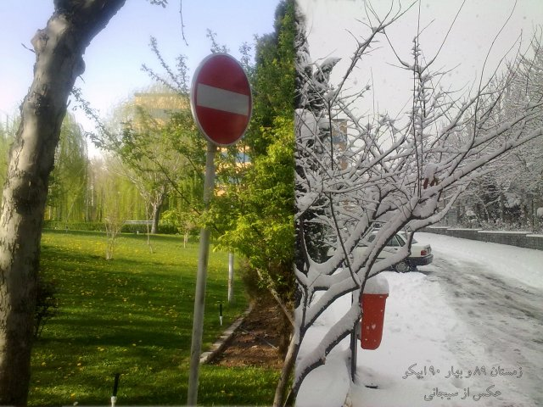
Figure 1: The figure name (at the center)

Results and Discussion
All obtained results should be carefully investigated and compared with the other works.

Conclusions
Main conclusions of the paper must be put here. Don't put any tables or figures, here.

Acknowledgment (optional)
If there is any acknowledgement is required, it can be mentioned here.

List of Symbols
E | modulus of elasticity, GPa
k | stiffness, N/mm²
p | acoustical pressure, Pa

References
All references and sources cited in the manuscript must be formatted according to the Vancouver Style, which relies on a sequential numbering system in the text and a corresponding reference list in the same order at the end of the article. It is emphasized that if a Digital Object Identifier (DOI) exists for any source, it must be included at the end of the reference and presented as an active hyperlink using the prefix https://doi.org/ to ensure direct and easy access to the original source. Furthermore, for all non-English sources, particularly Persian sources, authors are required to provide the title of the source in either translated or transliterated (Latin-script) form within the reference entry, and must append the phrase [In Persian] in square brackets at the end to clearly indicate the linguistic nature of the work for international reviewers and readers. Compliance with this structure is mandatory for all types of references, including journal articles, books, technical reports, and conference proceedings, and failure to comply will result in the manuscript being returned for revision.
[1] Docquier N, Candel S. Combustion control and sensors: a review. Progress in energy and combustion science. 2002 Jan 1;28(2):107-50. https://doi.org/10.1016/S0360-1285(01)00009-0
[2] Heywood J. Internal combustion engine fundamentals. 2018.
[3] Amjadi M, Moosavian SA, Rahimi Asiabaraki H. Developing a virtual reality simulator for skill enhancement; case study: the assembly process of the EF7 national engine's timing belt. The Journal of Engine Research. 2025 Aug 23;72(2):43-55. https://doi.org/10.22034/er.2025.2069278.1101 [In Persian]
[4] Salehi F, Moosavian A, Hashemi Daryan J, Moqtaderi H. Acoustic signal-based misfire detection in internal combustion engines using machine learning techniques. The Journal of Engine Research. 2026 Feb 20;72(4):1-20. https://doi.org/10.22034/er.2026.2076337.1107
[5] Ravaglioli V, Ponti F, Silvagni G, Moro D, Stola F, De Cesare M. Performance assessment of gasoline PPC in a light-duty CI engine. InWCX SAE World Congress Experience 2022 Mar 29. SAE Technical Paper. https://doi.org/10.4271/2022-01-0456

↑ If possible, equalize columns on the last page ↑

